Profee User Guide

Logging In

- Click on the attached link https://select.elantis.com.au/login.aspx?ReturnUrl=%2f
- Enter your username and password, click Login

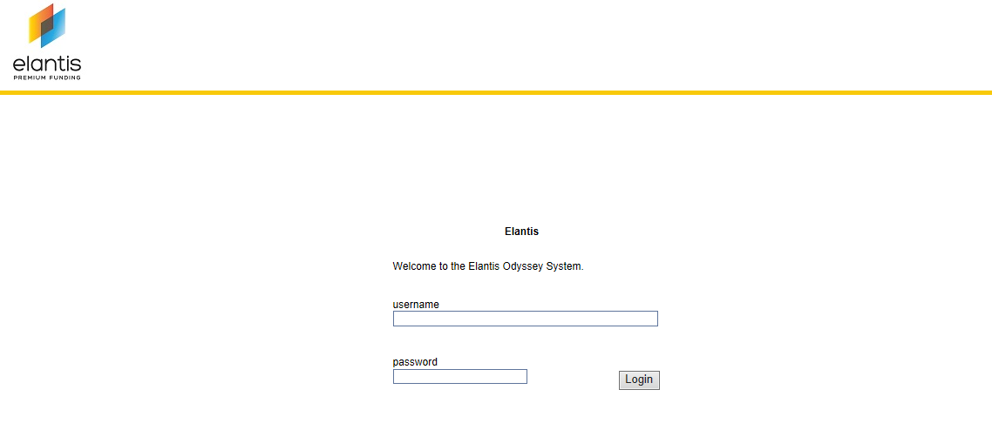
- You’ll will then see the below page

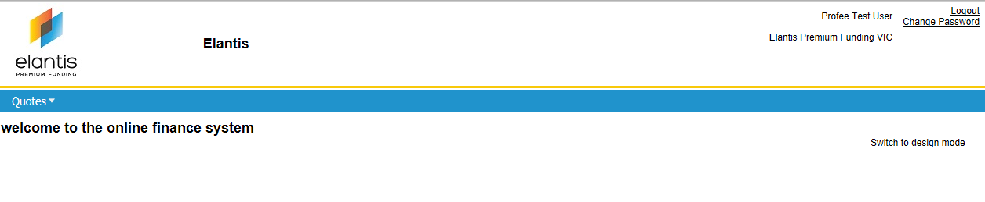
Quoting

Click on Quotes, you will then have two options, New Quote or Browse / Find Quotes

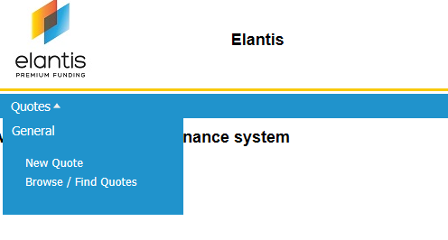
- New Quotes is used to create new quotes and produce the contract
- Browse/Find Quotes is used to search on existing quotes

New Quotes

To create a new quote click on New Quote, you will then see the below screen

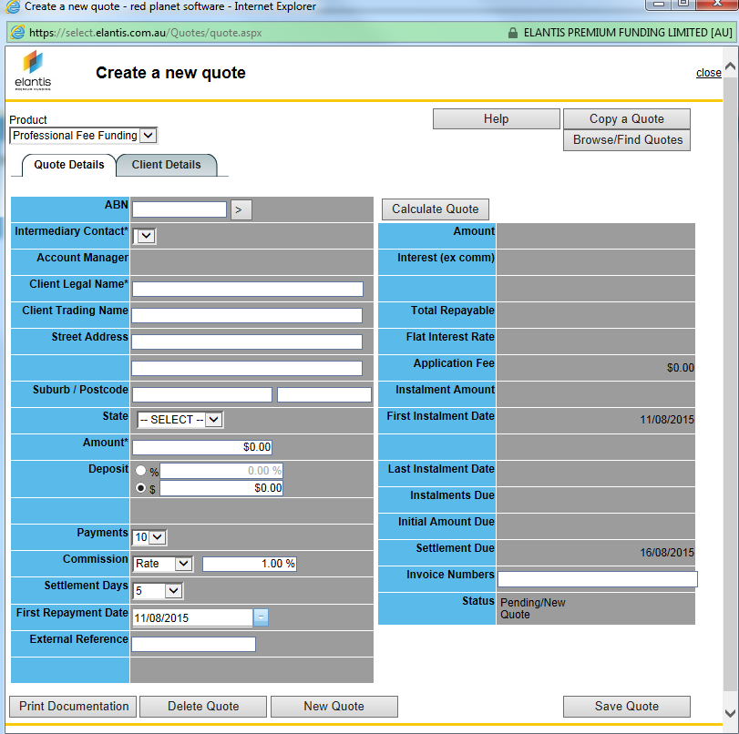

- Complete the following fields in the Quote Details tab
  - ABN if known
  - Client Name and Address
  - Amount, this is the total amount of the invoices
  - Deposit amount if applicable
  - Payments, this is the number of monthly instalments
  - Commission
  - Settlement Days, this will default to 5 and will be 5 days from when the signed contract is received
  - First Repayment Date, this will be the date the signed contract is received by us
  - Invoice Numbers, this is the invoice numbers of what we are funding, use a comma to separate each

- Then go to the Client Details tab and complete all the relevant fields, ie Postal Address, Phone, Mobile, etc.

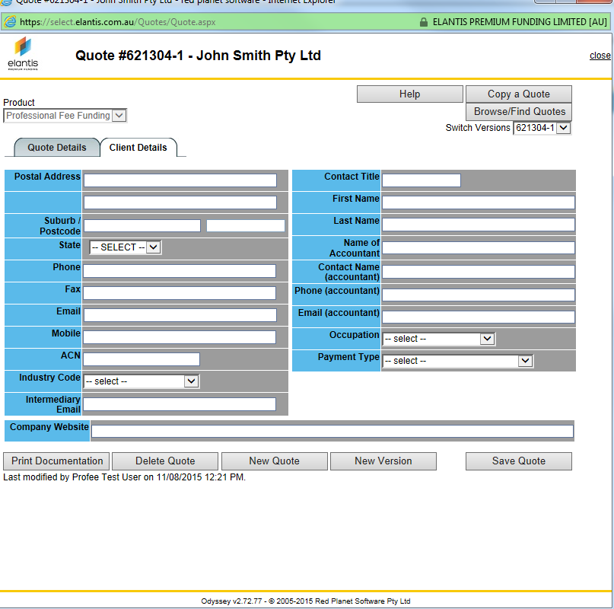

- Click on Save Quote, a Quote number will now be displayed on the top right hand corner
- Go back to the Quote Details tab and click the Calculate Quote Button on the top

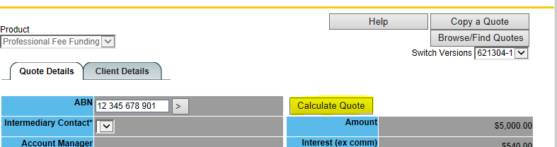

Printing/emailing a quote

To print the contract click on the Print Document button on the bottom left hand corner

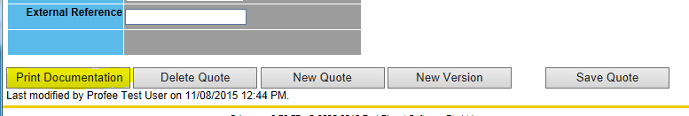

You will then get the below screen

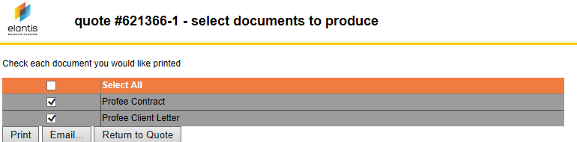

You can then Print the documents, this creates a PDF which can then be saved or you can click on Email which will then allow you to email it.

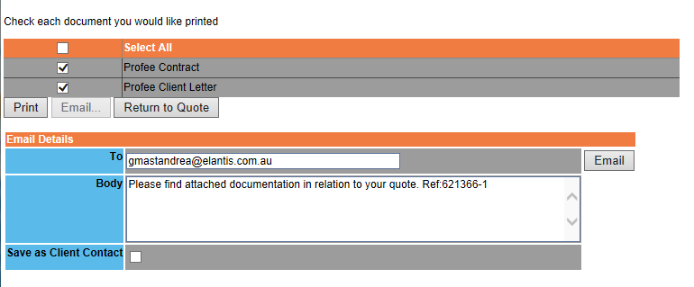

A copy of the Final contract is below. It will also print the terms and conditions and the client letter.

